Children’s cells live on in mothers
BY LAURA SANDERS 6:00AM, MAY 10, 2015

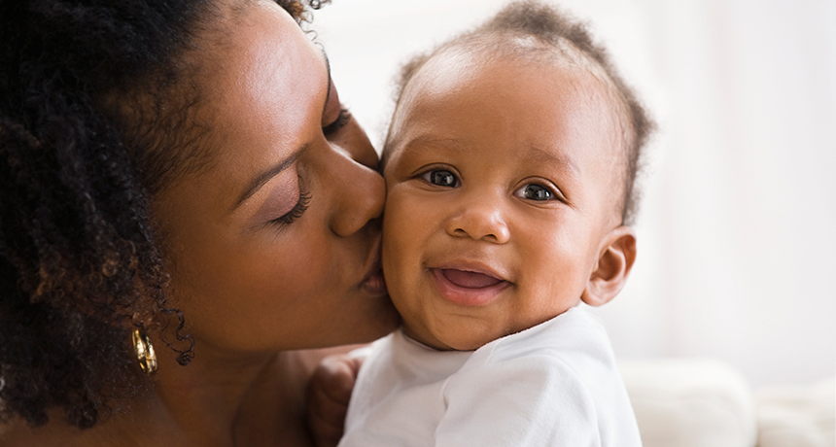
Mother’s Day is on my mind, and I’ve been thinking about the ways I’m connected to my mom and my two little daughters. Every so often I see flickers of my mom in my girls — they share the lines around their smiles and a mutual adoration of wildflowers. Of course, I’m biased. I know that I’m seeing what I’m looking for. But biologically speaking, mothers and their children are connected in a way that may surprise you.
Way back when you and your mom shared a body, your cells mingled. Her cells slipped into your body and your cells circled back into her. This process, called fetal-maternal microchimerism, turns both mother and child into chimeras harboring little pieces of each other.
Cells from my daughters are knitted into my body and bones and brain. I also carry cells from my mom, and quite possibly from my grandma. I may even harbor cells from my older brother, who may have given some cells to my mom, who then gave them to me. It means my younger brother just might have cells from all of us, poor guy. This boundary blurring invites some serious existential wonder, not least of which might involve you wondering if this means your family members really are in your head.
These cellular threads tie families together in ways that scientists are just starting to discover. Here are a few of my favorite instances of how cells from a child have woven themselves into a mother’s body:
- Fetal cells are probably sprinkled throughout a mother’s brain. A study of women who had died in their 70s found that over half of the women had male DNA (a snippet from the Y chromosome) in their brains, presumably from when their sons were in the womb. Scientists often look for male DNA in women because it’s easier than distinguishing a daughter’s DNA from her mother’s. If DNA from daughters were included, the number of women with children’s cells in their brains would probably be even higher.
- When the heart is injured, fetal cells seem to flock to the site of injury and turn into several different types of specialized heart cells. Some of these cells may even start beating, a mousestudy found. So technically, those icky-sweet Mother’s Day cards may be right: A mother really does hold her children in her heart.
- Fetal cells circulate in a mother’s blood. Male DNA turned up in blood samples from women who were potential stem cell donors. That result may have implications for stem cell transplants. This cell swapping may make parents better donor candidates for their children than strangers, for instance.
Other studies have found fetal cells in a mother’s bones, liver, lungs and other organs, suggesting that these cells have made homes for themselves throughout a mother’s body. Maybe this is a way for a child to give back to the mother, in a sense. Growing fetuses slurp nutrients and energy out of a mother’s body during pregnancy (not to mention the morning sickness, heartburn and body aches). In return, fetuses offer up these young, potentially helpful cells. Perhaps these fetal cells, which may possess the ability to turn into lots of different kinds of cells, can help repair a damaged heart, liver or thyroid, as some studies have hinted.
Before I get carried away, a caveat: these cells may also make mischief. They may have a role in autoimmune disorders, for instance.
Microchimerism also has implications here for women who have lost pregnancies, an extremely common situation hidden by the taboo of talking about miscarriages. Fetal cells seem to migrate early in pregnancy, meaning that even brief pregnancies may leave a cellular mark on a woman.
Scientists are just starting to discover how this cellular heritage works, and how it might influence health. The scientist in me can’t wait to see how this story unfolds. But for now, I’m content to marvel at the mother and daughters in me.

